Speech Emotion Recognition Using Machine Learning

Igor KOCIK ¹, Szymon SOBIECH², Juliusz KORC ³

- Student ID: 247091 e-mail: 247091@edu.p.lodz.pl
- Student ID: 247101 e-mail: 247101@edu.p.lodz.pl
- Student ID: 247092 e-mail: 247092@edu.p.lodz.pl

Abstract: This project investigates speech emotion recognition using machine learning techniques. Two models were developed and evaluated: a Convolutional Neural Network (CNN) to extract spatial patterns from audio features and a Long Short-Term Memory (LSTM) network to capture temporal dependencies. The models were trained on combined datasets containing diverse emotional speech samples, with features like MFCCs and Zero Crossing Rate. The CNN outperformed the LSTM in accuracy, highlighting its effectiveness in emotion classification tasks.
Keywords: Speech Emotion Recognition, Machine Learning, Convolutional Neural Networks (CNN), Long Short-Term Memory (LSTM), Audio Feature Extraction
1. INTRODUCTION
Understanding emotions through speech is a fascinating challenge that combines human psychology and technology. Speech Emotion Recognition focuses on identifying a person’s emotional state based on their voice, making it an essential tool for building smarter and more empathetic systems. From improving customer service interactions to supporting mental health applications, recognizing emotions accurately can significantly enhance how machines interact with people in real-world scenarios.
The motivation behind this project lies in the increasing need for systems that can interpret human emotions naturally and effectively. As technology becomes more integrated into our daily lives, equipping machines with emotional awareness bridges the gap between artificial intelligence and human communication. The goal of this project is to create machine learning models that can classify emotions in speech with high accuracy, exploring both their strengths and challenges.
In the past, simpler machine learning techniques like Support Vector Machines (SVM) were used for emotion detection, relying on manually selected features. While these methods showed promise, they struggled to fully capture the richness and complexity of speech. More recent deep learning models, such as Convolutional Neural Networks (CNNs) and Long Short-Term Memory (LSTM) networks, offer new opportunities by automatically extracting features and learning patterns from data. However, challenges such as unbalanced datasets, preprocessing hurdles, and limited generalization remain.
2. MATERIALS AND METHODS
2.1. Data
The dataset used in this project represents emotional speech samples derived from four publicly available sources on the kaggle.com website: RAVDESS, CREMA-D, TESS, and SAVEE. These datasets contain recordings of actors and speakers expressing various emotions such as happiness, sadness, anger, fear, disgust, and neutrality through speech. Each dataset was selected to ensure diversity in speaker demographics, recording conditions, and emotional representation, offering a robust foundation for training machine learning models.
Dataset Overview:

Nature of Data: Structured, labeled audio data.
Size:
- RAVDESS: 1,440 audio files (actors of both genders expressing 8 emotions).
- CREMA-D: 7,442 audio files (91 speakers expressing 6 emotions at varying intensity levels).
- TESS: 2,800 audio files (7 emotions expressed by 2 female speakers).
- SAVEE: 480 audio files (male speakers expressing 7 emotions).
Number of Features:
Extracted features include Mel-Frequency Cepstral Coefficients (MFCCs), Zero Crossing Rate (ZCR), and Root Mean Square (RMS) energy.

Data Sources:
- RAVDESS (Ryerson Audio-Visual Database of Emotional Speech and Song): Available online, featuring professional actors expressing emotions in speech and song.
- CREMA-D (Crowd-sourced Emotional Multimodal Actors Dataset): Available online, including multimodal emotional expressions.
- TESS (Toronto Emotional Speech Set): Available online, designed to evaluate the perception of emotions in speech.
- SAVEE (Surrey Audio-Visual Expressed Emotion): Available online, containing male voices expressing a variety of emotions.

Data Visualization:
The dataset distribution was visualized to examine the balance of emotions.
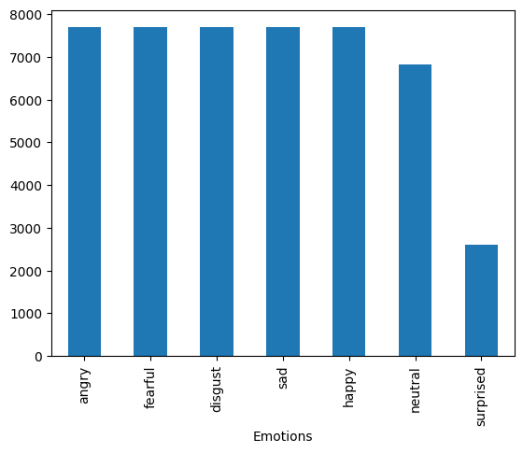
Fig. 1. Shows the number of samples for each emotion. This revealed a mostly balanced dataset.
Preprocessing Steps:
- Cleaning: Missing values were handled by replacing them with zeros in numerical fields.
- Feature Extraction: Audio features like MFCCs, ZCR, and RMS were extracted using the librosa library to represent speech characteristics.
- Normalization: Features were normalized to ensure consistency in scale and prevent bias during training.
- Padding: Audio samples were trimmed or padded to ensure a uniform length across the dataset.
- Encoding: Target feature - Emotions was encoded into numeric classes for compatibility with machine learning models.
Data Splitting:
The dataset splitting strategy differed between the CNN and LSTM models to align with their training approaches:
- CNN Model: Data was split into 80% training and 20% testing sets.
- LSTM Model: First 80% was assigned to training and 20% to testing. But than another 20% of the training set was used only for validation.
2.2. Methods
The speech emotion recognition process involved distinct steps for the two developed models: CNN and LSTM. Each model employed tailored methodologies optimized for their architectures. Below, we outline the process step by step.
Step 1: Data Preprocessing
Preprocessing was performed to standardize the raw audio data into features suitable for input into the models
Step 2: Splitting and Encoding
Data splitting strategies ensuring good and balanced training of the models.
Step 3: Model Architecture Design and Training
Architectures were determined using trial and error, as well as research. Training history was recorded for both the models.
Step 4: Evaluation
Both models were evaluated using the most effective methods such as accuracy, f1 score, precision, recall, and training efficiency.
Fig. 1. Flowchart of making the machine learning models.
2.3. Tools and technologies
The experiments for this project were conducted using a combination of hardware and software technologies designed to ensure efficient model training and reproducibility.
Hardware Setup:
The primary experiments were conducted on Kaggle's cloud-based environment, which provides the following hardware specifications:
- Processor: High-performance CPUs (e.g., Intel Xeon processors).
- GPU (optional): NVIDIA Tesla P100 or T4 GPUs with 16 GB VRAM (used for GPU-accelerated notebooks).
- RAM: 13 GB memory available by default.
- Storage:
  - 5 GB for input datasets.
  - 5 GB for notebook outputs.
  - Additional temporary storage during execution.
Software Environment:
- Programming Language: Python 3.9.
- Deep Learning Libraries:
  - TensorFlow 2.8.0: For defining and training CNN and LSTM models.
  - Keras: Integrated within TensorFlow for building and compiling models.
- Audio Processing Library:
  - Librosa 0.9.2: For feature extraction, such as MFCCs, ZCR, and RMS energy.
- Data Handling Libraries:
  - Pandas 1.4.3: For data manipulation and analysis.
  - NumPy 1.22.4: For efficient numerical computations.
- Visualization Tools:
  - Matplotlib 3.5.1 and Seaborn 0.11.2: For generating plots and heatmaps.
- Scikit-learn 1.1.1: For data preprocessing, such as scaling and one-hot encoding, and evaluation metrics (e.g., confusion matrix).
Additional Tools:
- Jupyter Notebook: Used for interactive code development and experiment tracking.
- Kaggle Notebook: For accessing datasets directly from Kaggle and executing code in an online GPU-accelerated environment.
2.4. Experimental setup
This section details the steps taken to implement and evaluate the CNN and LSTM models for speech emotion recognition. The experiments were designed to ensure robust training and fair comparison between the two architectures.
Feature Engineering
Feature Extraction: Using librosa, we extracted features such as:
- MFCCs: Representing the power spectrum of the signal.
- Zero Crossing Rate (ZCR): Capturing signal changes.
- Root Mean Square (RMS): Representing energy intensity.
Trimming and Padding: Audio files were trimmed to remove silence and padded to ensure uniform length across samples.
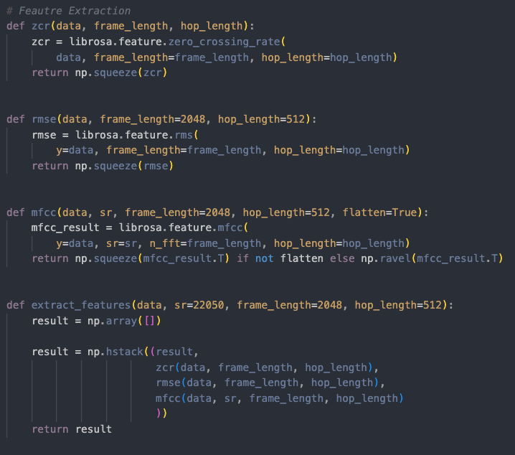
Alg. 1. Shows the feature extraction functions inside our code.
Augmentation: To further extend and generalize the data set, data augmentation was performed. Some recordings were duplicated with special effects added to them. The effects were adding noise, stretching, shifting, and changing the pitch
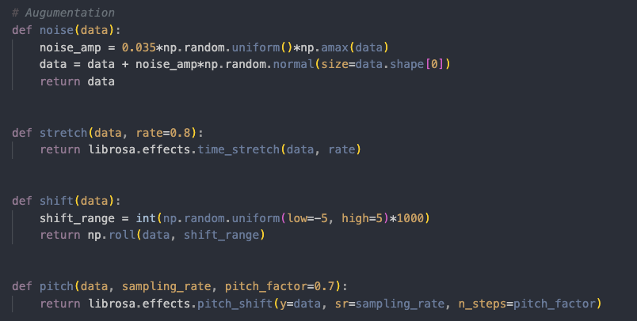
Alg. 2. Shows the Augmentation functions in the code.
Splitting
Data splitting strategies differed between models:
  - CNN: An 80%-20% split into training and testing sets.
  - LSTM: A three-way split (64% training, 16% validation, 20% testing).
Encoding and Normalization: Features were scaled using StandardScaler form sklearn.preprocessing package to bring them onto the same range, preventing dominance by any feature. Emotion (target) labels were encoded using One Hot Encoding for compatibility with categorical classification.
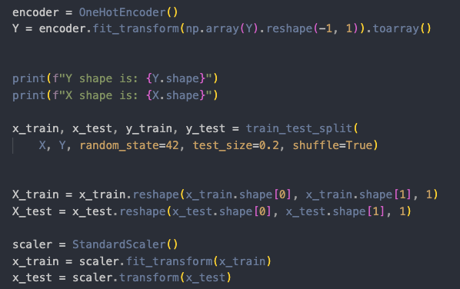Alg. 3. Encoding, normalization, and splitting inside the code.
Model selection
- Chosen Models:
CNN: Selected for its ability to learn spatial hierarchies in extracted features, making it well-suited for complex feature sets.
LSTM: Chosen for its effectiveness in capturing temporal dependencies, crucial for sequential data like speech.
- Alternatives Considered:
Traditional machine learning models (e.g., Support Vector Machines) were excluded due to their reliance on handcrafted features and limited scalability.
Ensemble methods like Random Forest were deemed unsuitable for sequential feature modeling.

- Rational for Final Selection:
CNN and LSTM architectures align closely with the project’s goal of leveraging deep learning to capture both spatial and temporal patterns in the audio features.
Model architecture and Hyperparameter Tuning
CNN Model:
The architecture is build of five main consecutive collections of layers, which are each made up of the convolutional layer, a batch normalization layer, and a max pooling layer. One the second, fourth and fifth collection there is also an additional dropout layer. At the end there is a flattening layer, a fully con-nected dense layer, a batch normalization layer and a dense softmax layer. The detailed configuration of each layer can be seen on Alg. 4.
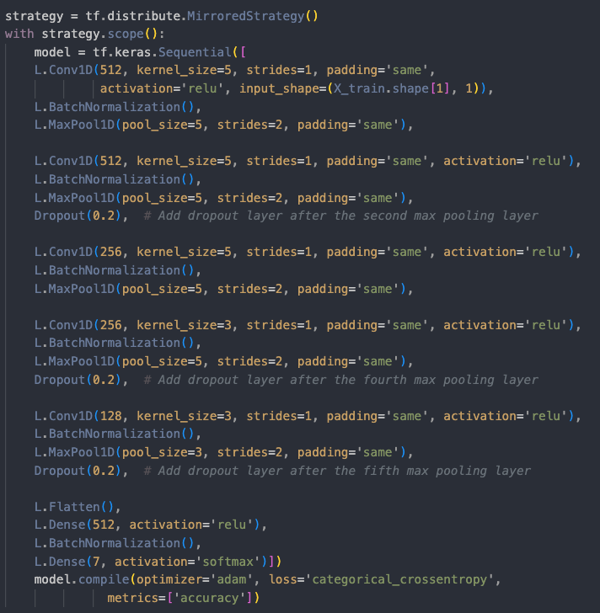
Alg. 4. Architecture of the CNN model.
The purpose of each layer is the following:
Input Layer: Accepts 1D audio feature arrays.
Convolutional Layers: Extract spatial hierarchies of features with increasing filters (e.g., 512, 256, 128).
Batch Normalization: Ensures stable and faster convergence.
MaxPooling Layers: Reduce dimension-nality after each convolutional block.
Dropout Layers: Added after key layers to prevent overfitting.
Dense Layers: Fully connected layers leading to the output layer with a softmax activation for emotion classification.
hyperparametrization
Filters: Experimented with filter sizes (128, 256, 512) for convolutional layers.
Kernel Size: Tested with kernel sizes (3, 5) to balance feature extraction precision and computational efficiency.
Dropout Rates: Tuned values (0.2) to mitigate overfitting.
Optimizer: Adam was chosen for adaptive learning, with initial learning rates.
LSTM Model:
The model contains a single LSTM layer, which also acts as an input layer, two fully activated dense layers, three dropout layers and a dense softmax layer at the end. The detailed configuration of each layer can be seen on Alg. 5.
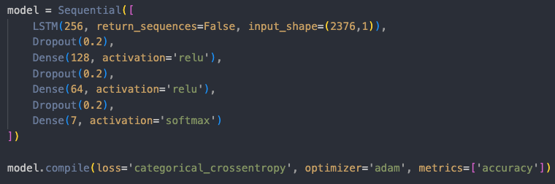
Alg. 5. Architecture of the LSTM model.
LSTM Layer: Learns temporal dependencies in the data and acts as an input layer.
Dense Layers: Help reduce dimensionality and outputs emotion classes using softmax activation.
Dropout Layers: Added to prevent overfitting.
Hyperparametrization
Number of Units: 256 units in the LSTM layer.
Dense Layers: Two dense layers are enough for dimensionality reduction. One softmax layer.
Batch Size: 64 to ensure training stability.
Learning Rate: Dynamic using learning rate reduction callback.
Tools: Hyperparameter tuning was conducted manually using validation accuracy as the primary metric.
Training Process
CNN: Training Process
- Initialize the model with predefined layers.
- Compile the model with Adam optimizer and categorical cross entropy loss.
- Train for 50 epochs with early stopping and learning rate reduction.
- Save the best model for evaluation.
The process can be seen on Fig. 2.
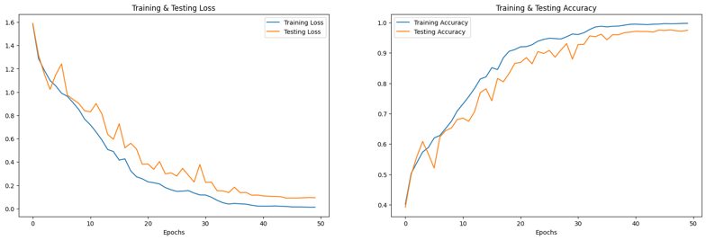
Fig. 2. The X axis on each plot represents the epoch number. The Y axis on the left in blue is training loss function, in yellow testing loss function. On the right it’s training accuracy and testing accuracy.
LSTM: Training Process
- Initialize the model an LSTM layer.
- Compile using adam optimizer, categorical crossentropy loss and accuracy metrics.
- Train for 500 epochs with a batch size of 64, using a learning rate reduction callback.
- Save the best model based on validation accuracy.
The training process of this model was difficult. It was very slow to learn compared to CNN it required significantly more training time, computational power, and a higher number of epochs. At first it collapsed every time very early on at about 20% accuracy. It was due to too high learning rate. After many different parametrization approaches, a decreasing the batch size and setting a learning rate reduction callback, it achieved a fairly stable training process. Unfortunately, after many hours of training, it eventually collapsed after reaching above 80% accuracy and still showing a lot of room for improvement.
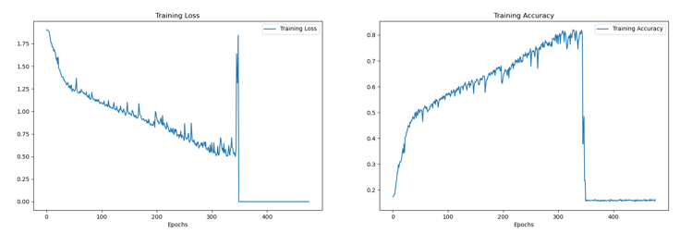
Fig. 3. The X axis on each plot represents the epoch number. The Y axis on the left is training loss function. On the right it’s training accuracy.
Evaluation Metrics
The models were evaluated using the following metrics:
Accuracy:
Indicates the percentage of correctly classified emotions out of all predictions.
Chosen as a primary metric to gauge the overall effectiveness of the models.
Confusion Matrix:
Visualizes classification performance across all emotion classes.
Provides insights into class-level accuracy and misclassification patterns.
Classification Report:
Includes precision, recall, and F1-score for each emotion class.
Precision: How many predicted positives are true positives.
Recall: How many actual positives are correctly predicted.
F1-score: Balances precision and recall for imbalanced datasets.
Experimental Rigor
Validation Techniques:
Cross-validation was used in the LSTM experiments to ensure the model generalizes well.
Early stopping and learning rate reduction were applied to prevent overfitting and optimize training efficiency.
Randomization:
Data was shuffled during training and testing splits to minimize bias.
Bias Mitigation:
The class imbalance in the datasets was identified and partially addressed through oversampling and weighted loss functions during model training.
By carefully designing and implementing these experimental steps, the models were evaluated comprehensively, ensuring a robust comparison of their capabilities.

3. RESULTS
This section presents the qualitative and quantitative results of the CNN and LSTM models developed for speech emotion recognition. The performance of both models is evaluated using accuracy, precision, recall, and F1-score. Visualization tools such as confusion matrices and training/validation curves are included to provide further insights into model behavior.
3.1. Quantitative Results
- Accuracy:
The CNN model achieved an accuracy of 98% on the test set, outperforming the LSTM model, which collapsed at an accuracy of around 80%. Though with greater computing or longer available computing time, which would allow us to further slow down the learning process and increase stability, the LSMT model showed potential to achieve similar or even better results.
I’s worth noting that CNN required significantly shorter training time. CNN trained for around 2-3 hours, and LSTM collapsed after around 13-15 hours.
- Classification Report:
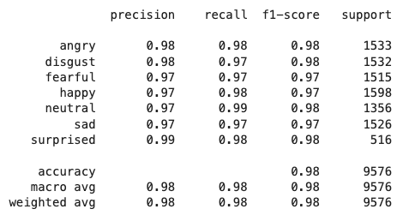
Fig. 4. The classification report for CNN.
Confusion Matrix:
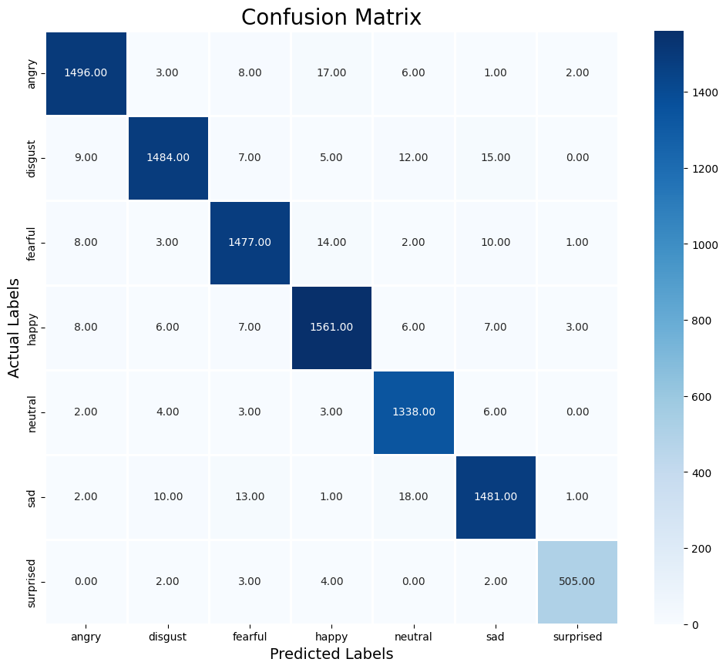
Fig. 5. shows the confusion matrix for the CNN model. The diagonal values represent correctly predicted instances, while off-diagonal values indicate misclassifications.
3.2. Qualitative Results
Best, Worst, and Average Cases:
The CNN model performed really well on all the predicted emotions every time, all the evaluation tries were good. The LSTM couldn’t be evaluated. In training at first it couldn’t reach 20% of accuracy, after parametrization it improved to 70-80%, and crashed at some unexpected moment. Unfortunately training time available on Kaggle for free ended, so this couldn’t be improved further.
3.4. Computational Resources
Execution Time:
Training the CNN model took approximately 2 minutes per epoch, while the LSTM model required 1.5 minute per epoch due to its sequential processing overhead. But the number of epochs had to be significantly longer for LSTM. The total training time for CNN was less than 2 hours, while for LSTM it was less than 13 hours.
Memory Usage:
The CNN model consumed less memory during training and inference compared to the LSTM, making it more resource efficient.
4. DISCUSSION
4.1. Interpretation of Results
The CNN model consistently outperformed the LSTM model in accuracy, F1-score, and training efficiency. This indicates that spatial feature extraction from MFCCs, ZCR, and RMS energy is well-suited to the CNN architecture. In contrast, the LSTM, while designed to capture temporal dependencies, struggled with this dataset due to factors such as strongly varying sound wave forms, without clear patterns.
Patterns observed in the confusion matrices further supported these findings:
Neutral and Happy emotions: Classified with high accuracy, reflecting their distinct acoustic features.
Sad and Angry emotions: Were slightly more often misclassified, likely due to overlapping acoustic patterns, suggesting these classes share similar pitch and tone characteristics.
These results align with expectations for feature-based classification while revealing the limitations of sequential modeling for this specific dataset.
4.2. Strengths and Weaknesses
Strengths:
CNN model proved to be a great option for emotion recognition, reaching good accuracy, in relatively short training time. This model can predict greatly the speech in our data sets.
Weaknesses:
The LSTM was very inefficient in this particular use case. It was difficult to train and required far more computing power to reach the same results.
It’s hard to say how good the speech recognition in any model would be outside of data sets, where it could encounter words and sounds it has not analyzed before.
4.3. Limitations and Challenges
Instability of training of the LSTM model
Due to too high learning rates the LSMT model collapsed during training. The slower rates were inefficient, as the CNN achieved great results with significantly less training.
Dataset Size and Imbalance:
The limited number of samples for certain emotions impacted model performance, particularly for the LSTM. Oversampling or class-weight adjustments partially mitigated this, but a larger, balanced dataset would improve results.
Overfitting:
Both models exhibited signs of overfitting during training. Regularization techniques (e.g., dropout and early stopping) helped reduce this but did not fully eliminate it.
Unexpected Results:
Certain emotions, like Angry and Fear, were more often confused, contrary to expectations based on distinct emotional tones. This may stem from speaker-specific variations or noise in the dataset.
4.4. Applicability and Scope
The models developed in this project demonstrate strong potential for applications in fields such as:
Human-Computer Interaction: Enhancing virtual assistants and chatbots with emotion recognition capabilities.
Mental Health Monitoring: Assisting in detecting emotional states in therapeutic or diagnostic contexts.
Education: Providing adaptive learning experiences based on student emotions.
However, their applicability is limited by dataset constraints and the need for domain-specific training. Models must be retrained with representative data for deployment in diverse environments.
4.5. Future Research and Improvements
To address the identified challenges and limitations, future work could focus on the following:
Dataset Expansion:
Collecting or integrating larger datasets with diverse speakers and balanced emotion classes.
Raw Audio Modeling:
Implementing end-to-end models like WaveNet or spectrogram-based CNNs to reduce dependency on handcrafted 3
Advanced Architectures:
Exploring hybrid models combining CNNs and LSTMs for improved spatial-temporal learning.
Feature Engineering:
Investigating additional features such as chroma, spectral contrast, or time-frequency representations.
Cross-Dataset Generalization:
Testing the models on external datasets to evaluate robustness and transferability.

4.6. Ethical Considerations
Privacy Concerns:
Speech data inherently contains sensitive information. Models must be deployed with stringent privacy measures to protect users.
Bias in Data:
Imbalances in gender, language, and cultural representation in the datasets could lead to biased predictions, which must be mitigated through careful dataset curation.
Misuse of Technology:
Emotion recognition systems could be misused in surveillance or coercive applications. Ethical guidelines should govern the deployment of such technologies.
5. CONCLUSIONS
This project explored the use of machine learning methods for speech emotion recognition, comparing the performance of Convolutional Neural Networks (CNNs) and Long Short-Term Memory (LSTM) models. The most important findings highlight the advantages of CNNs in learning spatial patterns from audio features and their superior performance over LSTMs for this task.
Key Achievements
CNN Model: Achieved higher accuracy and faster convergence, demonstrating its ability to efficiently process audio features like MFCCs, ZCR, and RMS energy.
LSTM Model: Showed potential in capturing temporal dependencies but struggled with the dataset size and imbalances, resulting in unstable training.
Successfully implemented preprocessing techniques, including feature extraction, normalization, and data splitting, to prepare the dataset for training both models.
Challenges and Shortcomings
Dataset Limitations:
The limited size and imbalance of emotion classes affected the performance, particularly for the LSTM model.
Some emotions were frequently misclassified, likely due to overlapping acoustic patterns.
Model Limitations:
The CNN relied heavily on handcrafted features, limiting its ability to generalize to raw audio data.
The LSTM required significant computational resources and exhibited slower training, making it less efficient for this project.
Despite these challenges, the project effectively demonstrated the potential of deep learning in speech emotion recognition and identified areas for future improvement.
Lessons Learned
The choice of model architecture plays a crucial role in handling specific types of features, such as spatial versus temporal dependencies.
Dataset quality, including size and balance, is critical for achieving reliable results, particularly with complex models like LSTMs.
Regularization techniques and careful tuning of hyperparameters are essential to mitigate overfitting and improve generalization.
Future Opportunities
This project opens avenues for further development in the following areas:
Improving Feature Representation: Exploring end-to-end models like spectrogram-based CNNs or raw audio processing architectures.
Dataset Expansion: Incorporating more diverse and balanced datasets to enhance model robustness.
Hybrid Architectures: Combining CNNs and LSTMs to leverage their strengths in spatial and temporal feature modeling.
Practical Applications: Extending the models to real-world systems, such as virtual assistants or mental health monitoring tools.
Final Remarks
This study highlights the feasibility of machine learning for speech emotion recognition, offering valuable insights into the strengths and limitations of CNNs and LSTMs. While the CNN demonstrated clear advantages in this project, the LSTM's sequential modeling capabilities suggest potential in different contexts or with larger datasets. The findings emphasize the importance of careful model selection, robust preprocessing, and ethical considerations in developing human-centered AI applications.
6. AUTHORS CONTRIBUTIONS
The following contributions were made by each author, categorized according to the CRediT (Contributor Roles Taxonomy):
Juliusz Korc:
Conceptualization: Contributed to the research and planning of the project.
Methodology: Designed and implemented the CNN model.
Data Curation: Prepared and preprocessed the data for the CNN experiments, including feature extraction and normalization.
Validation: Conducted testing and evaluation of the CNN model.
Visualization: Created visualizations such as training curves, confusion matrices, and CNN-related performance metrics.
Writing – Original Draft Preparation: Wrote the sections of the report related to the CNN methodology and results.
Igor Kocik:
Conceptualization: Contributed to the research and planning of the project.
Software: Developed and implemented the LSTM model in collaboration with Szymon.
Hyperparameter Tuning: Optimized the LSTM model's performance through tuning and validation.
Investigation: Analyzed the LSTM model's performance and compared it to the CNN model.
Writing – Review & Editing: Reviewed and refined the LSTM-related sections of the report.
Szymon Sobiech:
Conceptualization: Contributed to the research and planning of the project.
Software: Collaborated with Igor to develop the LSTM model.
Validation: Performed testing and validation for the LSTM model.
Formal Analysis: Interpreted the LSTM results, including precision, recall, and F1-score metrics.
Resources: Ensured proper use of the Kaggle environment and computational resources for the LSTM experiments.
Writing – Original Draft Preparation: Co-authored the LSTM methodology and results sections.
7. REFERENCES
- Ryerson Audio-Visual Database of Emotional Speech and Song (RAVDESS).
https://www.kaggle.com/datasets/uwrfkaggler/ravdess-emotional-speech-audio
- CREMA-D: Crowd-sourced Emotional Multimodal Actors Dataset.
https://www.kaggle.com/datasets/ejlok1/cremad
- Toronto Emotional Speech Set (TESS).
https://www.kaggle.com/datasets/ejlok1/toronto-emotional-speech-set-tess
- Surrey Audio-Visual Expressed Emotion Database (SAVEE).
https://www.kaggle.com/datasets/ejlok1/surrey-audiovisual-expressed-emotion-savee

